**WINDOWS SERVER USER AND GROUP PERMISSION CONFIGURATION**

The C:\Shared folder contains a folder for each department (HR, Sales and IT) and a personal folders for each users.

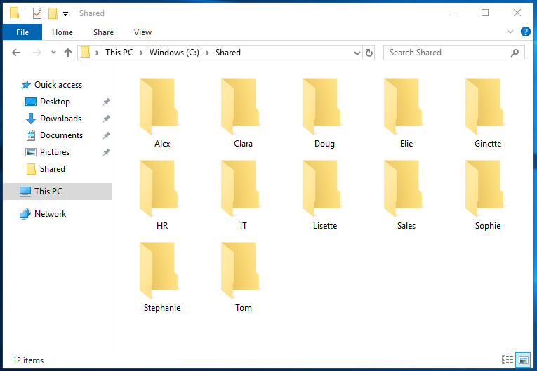

Users for each of the departments or group are listed below:

* + - * **Sales:** Tom, Ginette, Clara
      * **HR:** Stephane, Alex, Sophie
      * **IT:** Doug, Lisette, Elie

For the **C:\Shared** folder, all authenticated users only have read write and execute permission, but the administrator and the system have full control.

The administrator and the system also have full control of all sub-folders.

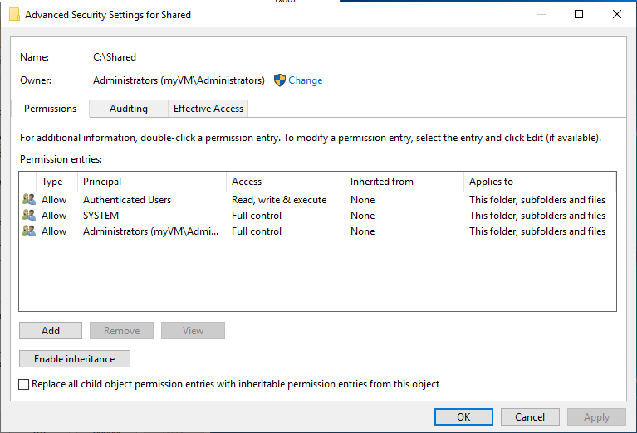

The **C:\Shared** folder is a shared folder on the network with the path **\\myVM\Shared**

The HR IT and Sales folders are also shared. Although everyone has read permission over the network for the Shared, HR, IT and Sales folder, specific permissions have been assigned to individuals according to their respective departments. Personal folders are only accessible by the administrator and the actual user over the network.

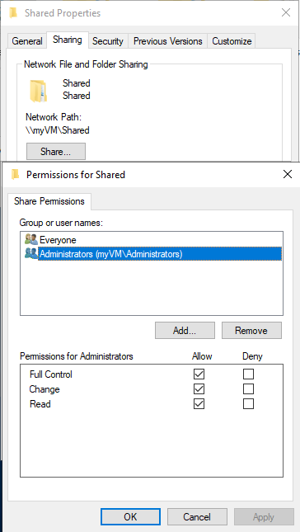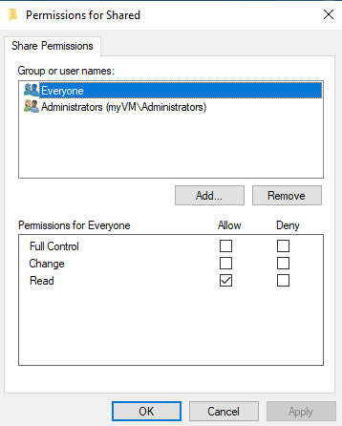

Only members of the HR group have read write and execute permission in the HR folder. Users from other departments only have read and execute permission.

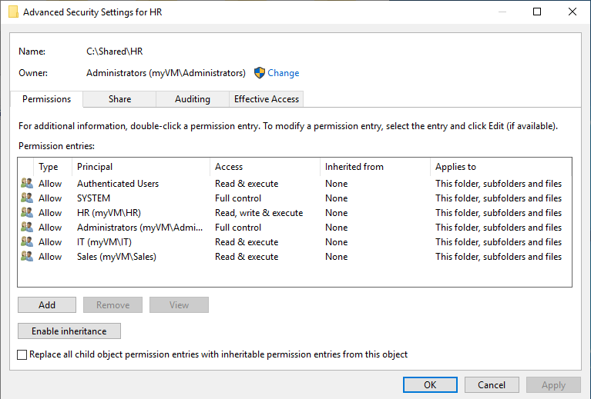

Only members of the IT group have read write and execute permission in the IT folder. Users from other departments only have read and execute permission.

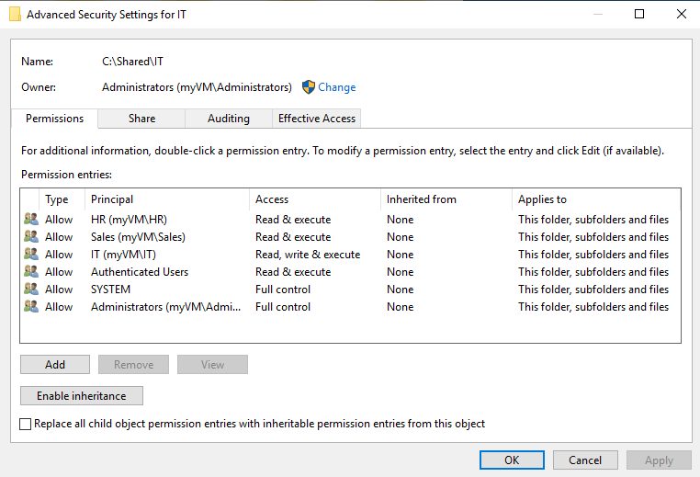

Only members of the Sales group have read write and execute permission in the Sales folder. Users from other departments only have read and execute permission.

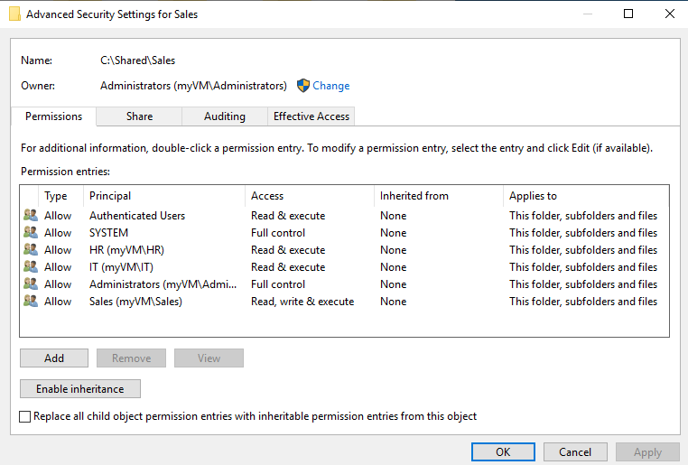

In all the personal folders, only the administrator, the system, and the actual user themselves have full access permission.

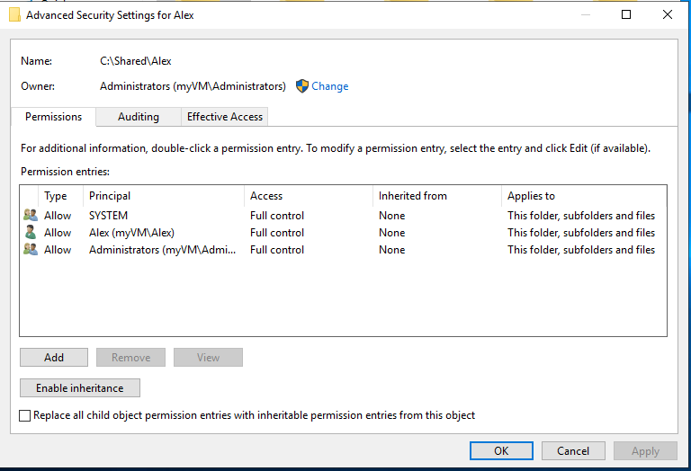

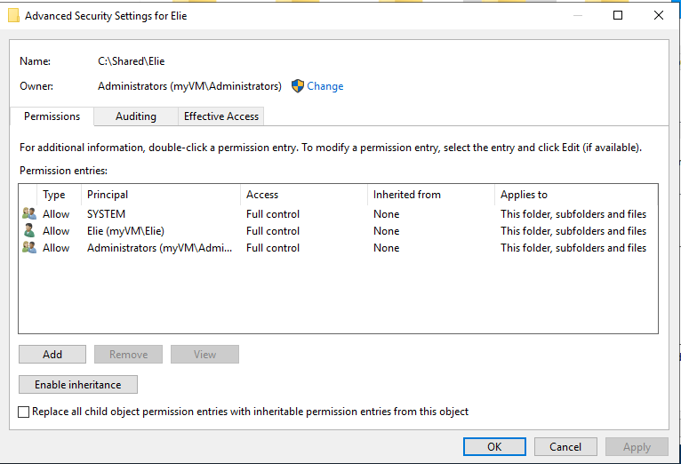

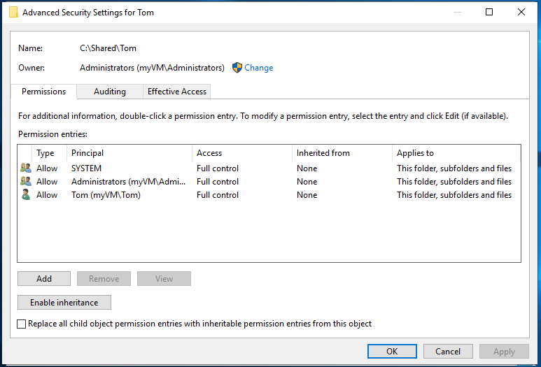

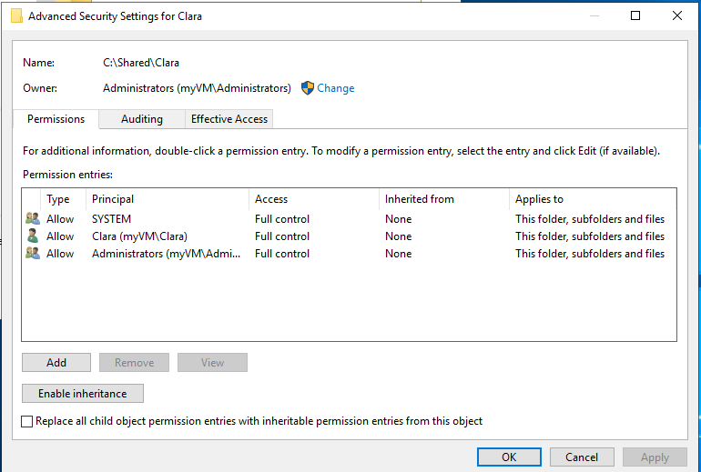

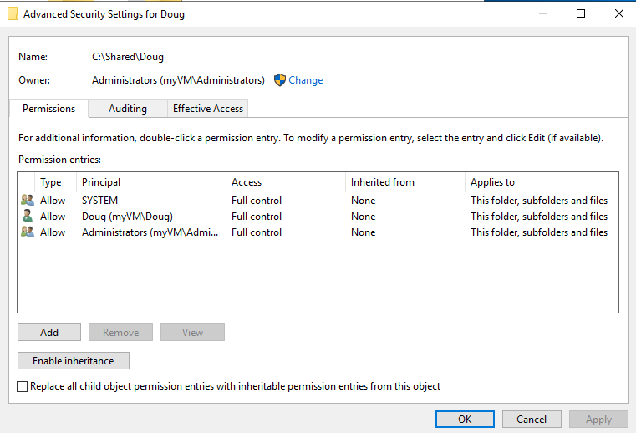

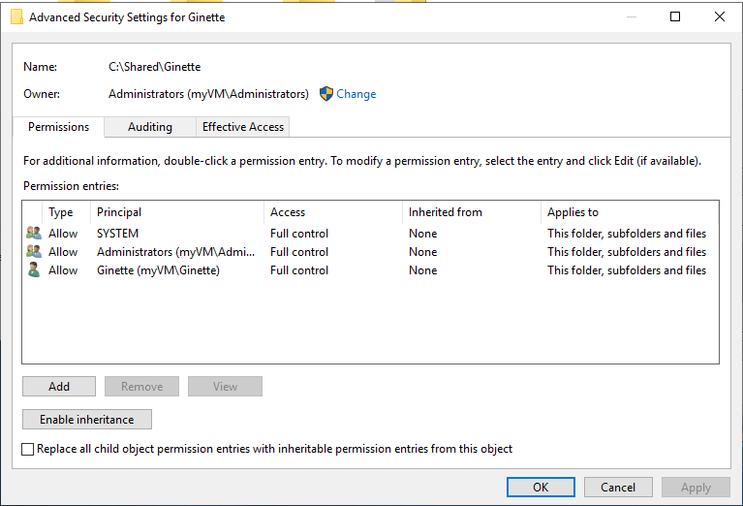

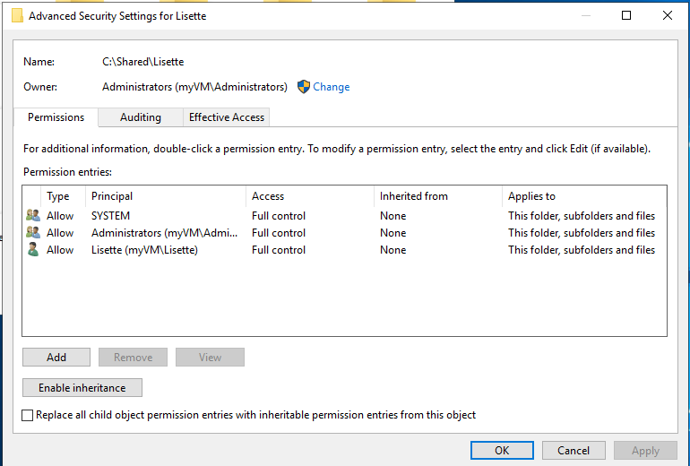

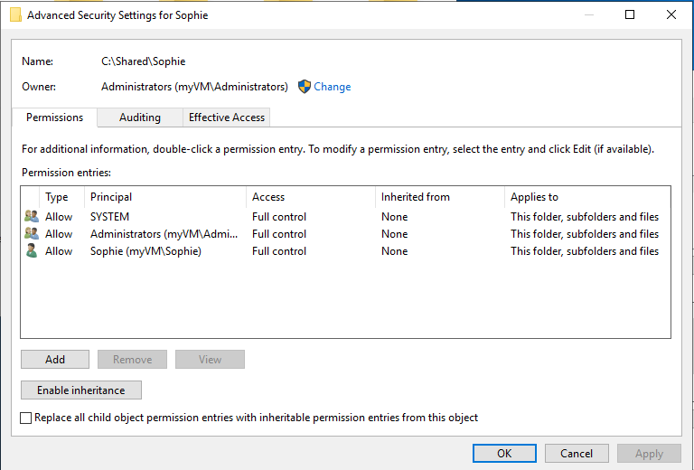

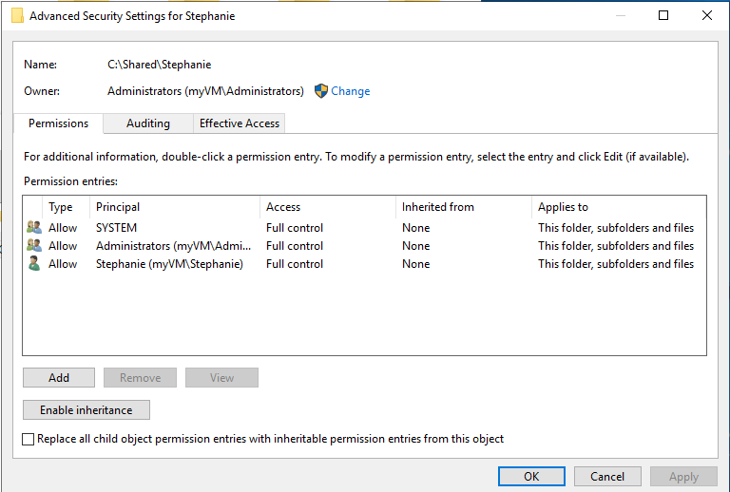

***SQL SERVER 2019 and SQL Server management Studio installed***

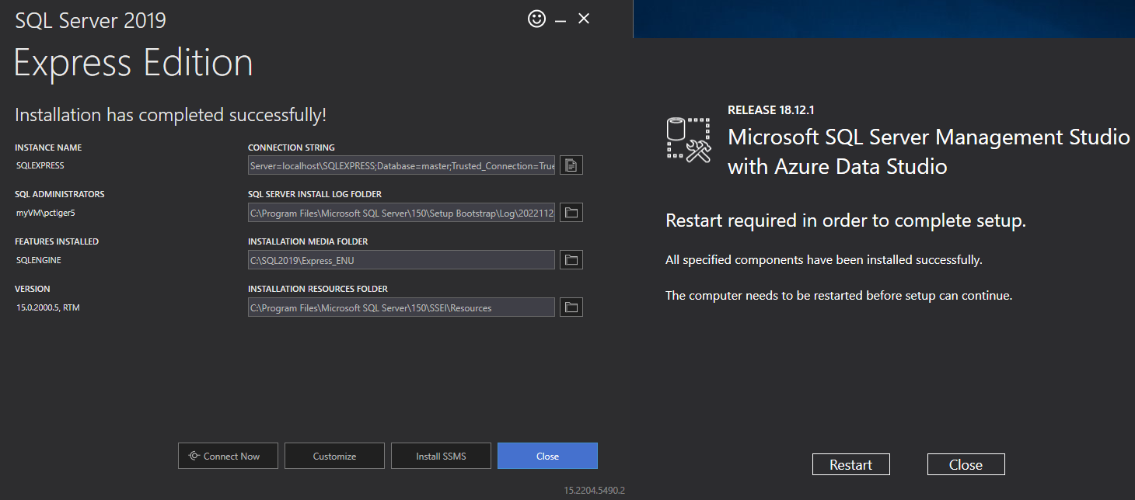

***Connecting with SQL Server Management Studio***

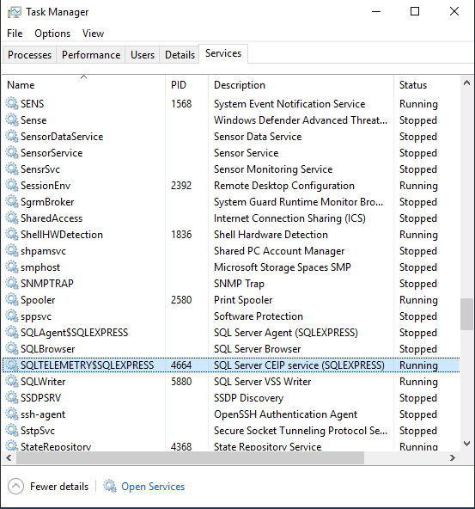

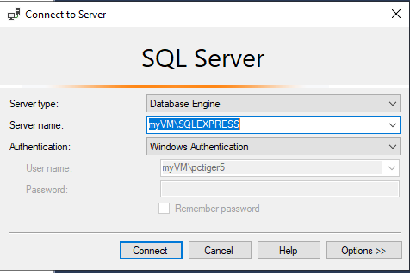

***Connected to*** *myVM\SQLEXPRESS server*

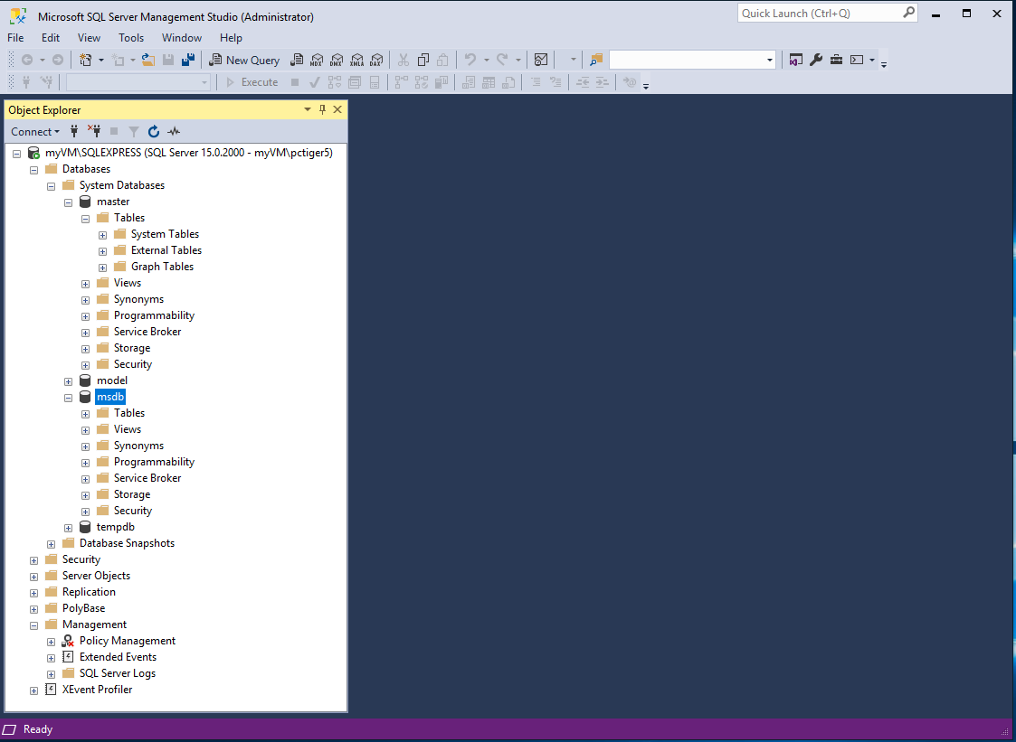

**LINUX SERVER**

**Installing the apache2 web server**

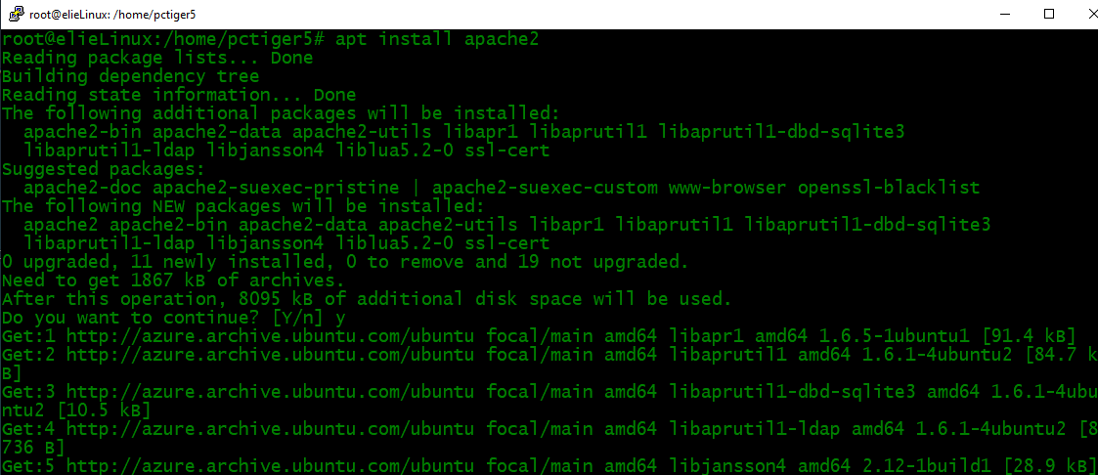

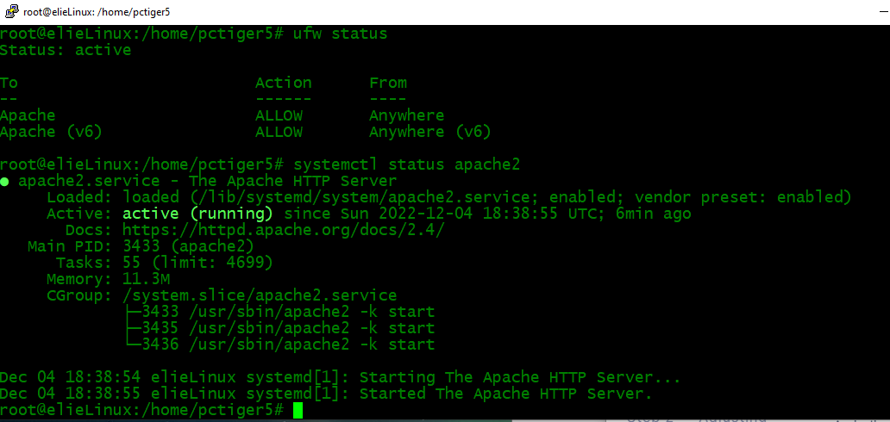

**Editing HTML file**

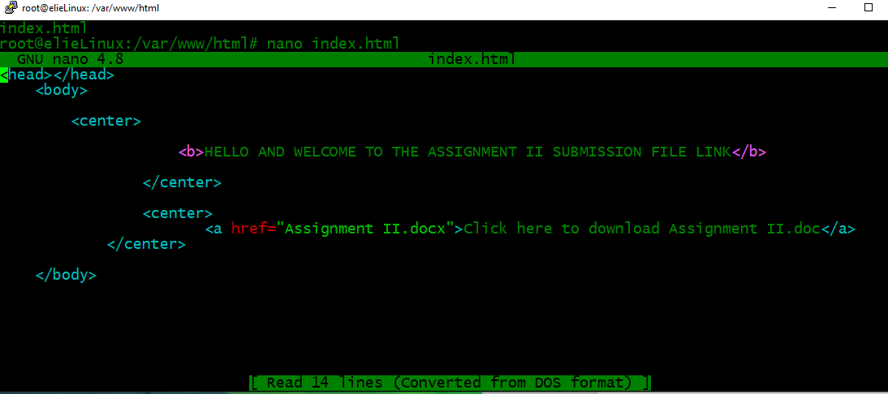

**Opening port 80 and allowing SSH**

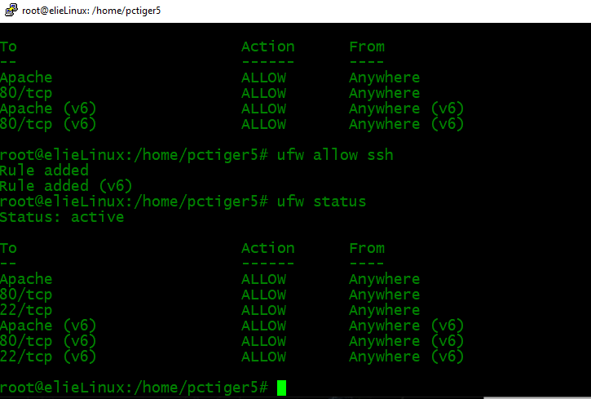

**Connecting to the server via WinSCP**

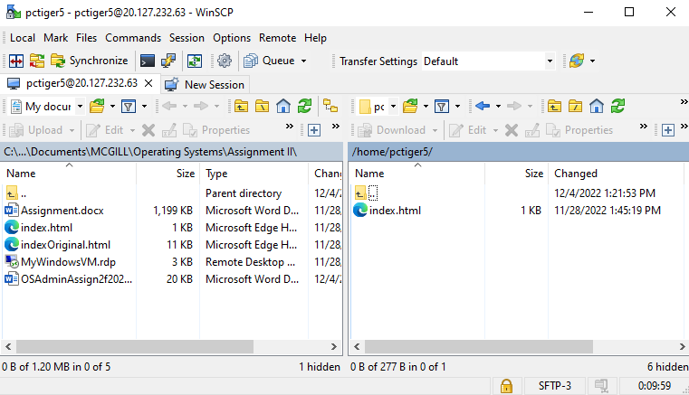

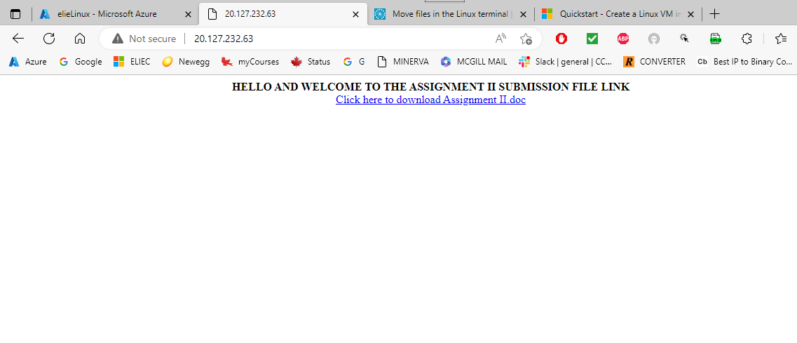

**Transferring Assignment II.docx to the server var/www/html/ folder**

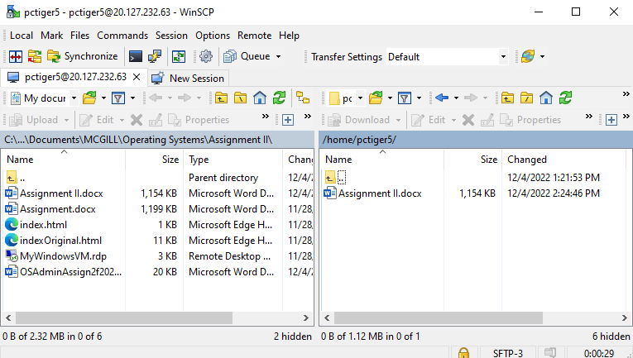

**Installing my SQL**

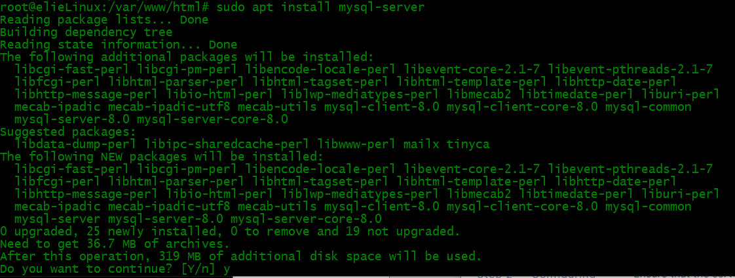

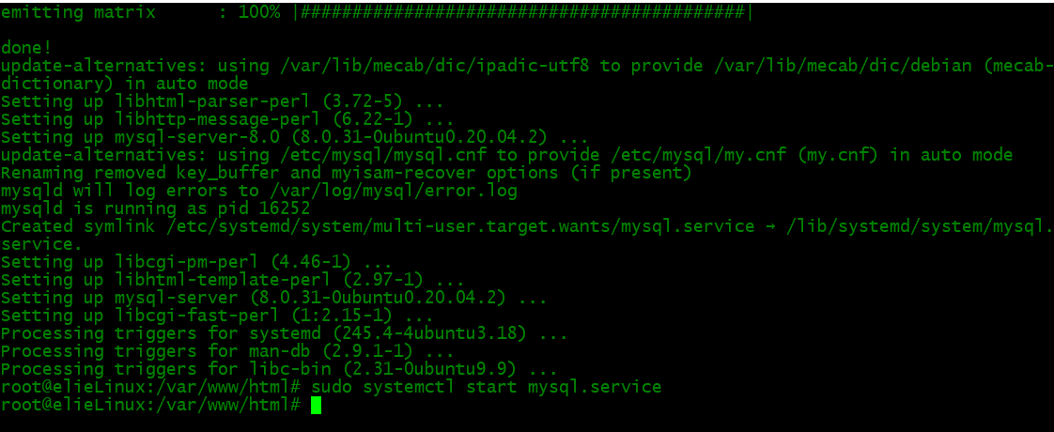

**Making sure SQL is running**

